

DEPARTMENT OF INFORMATION TECHNOLOGY
SCHOOL OF COMPUTING AND INFORMATICS

LOGBOOK: MOBILE APPLICATION DEVELOPMENT
UNIT CODE: BIT4107
NAME: YUSUF ANEMBA
REGNO: BIT/2020/90745
PROJECT NAME: SCHOOL MANAGEMENT APPLICATION

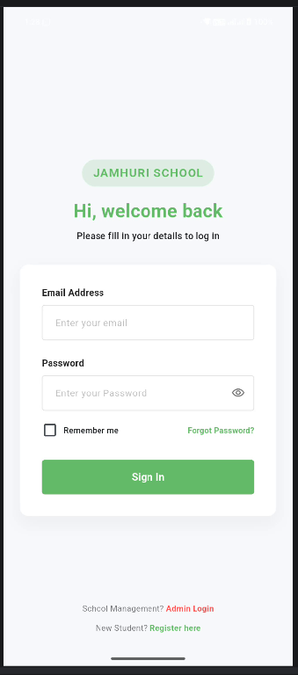
Figure 1.1 login screen for the students with an admin login option at the bottom
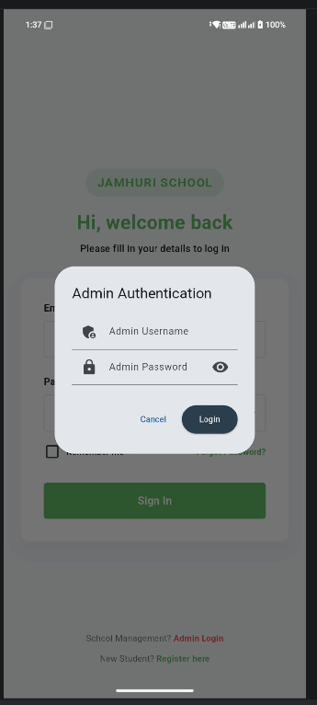
Figure 1.2 admin login screen of the student mobile application
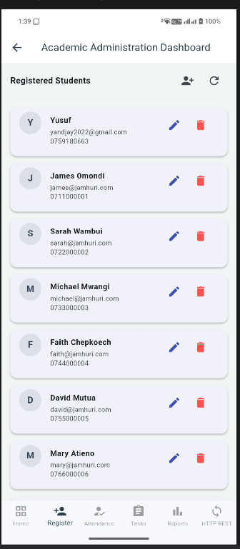
Figure 1.3 students’ details with an option to add a student directly from the admin panel
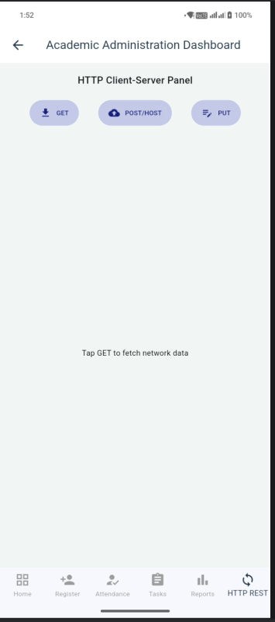
Figure 1.4 Network panel

TOOLS AND TECHNOLOGIES USED
For the development of the JAMHURI STUDENT MANAGENT APP, I used the following tools,
- Flutter SDK
- Dart
- SQFlite. Local database to store students’ records.
- Android studio
- Android emulator/ my android phone
- Visual Studio Code (VS Code)
- Windows PowerShell (as Administrator)
- IPConfig (ipconfig)
- Windows Defender Firewall
- Windows .NET System.Net.HttpListener
- Chrome web

